REPORT

Deep Learning Image Classification
Using Transfer Learning with ResNet18 on the CIFAR-10 Dataset
Implemented in PyTorch on Google Colab (Tesla T4 GPU)
Submitted by: | Aishwarya Manohar Rane
Course: | CSE AIML
Internship Company: | Alfido Tech

1. Introduction
Image classification is one of the fundamental tasks in computer vision. It involves assigning a label to an image from a fixed set of categories. Deep learning, and in particular Convolutional Neural Networks (CNNs), has become the standard approach for this task because CNNs learn useful visual features directly from raw pixels instead of relying on hand-crafted features.
Training a deep CNN from scratch normally needs a very large dataset, considerable computing power and a long training time. Transfer learning reduces this cost by reusing a network that has already been trained on a large dataset (ImageNet) and adapting it to a new problem.
This report documents a deep learning image classification project in which a pretrained ResNet18 network was adapted to classify images of the CIFAR-10 dataset. The project was implemented in Python using the PyTorch framework on Google Colab with a Tesla T4 GPU. The report describes the data preprocessing and augmentation steps, the transfer learning setup, the training process, and the evaluation of the trained model using test accuracy, a classification report, a confusion matrix and sample predictions.

2. Problem Statement
Given a small colour image of 32 × 32 pixels, the task is to automatically assign it to one of ten object categories: airplane, automobile, bird, cat, deer, dog, frog, horse, ship and truck.
The problem is challenging for several reasons:
- The images have very low resolution, so fine details are lost.
- Some classes are visually similar (for example cat and dog, or automobile and truck).
- Objects appear with large variations in pose, lighting, background and scale.
- Training a deep network from scratch requires significant time and computing resources.
This project therefore investigates how well a pretrained ResNet18 network, with only its final classification layer retrained, can solve the CIFAR-10 classification problem within a short training time.

3. Objectives
The main objectives of the project were:
- To load and prepare the CIFAR-10 dataset for training and testing.
- To apply image preprocessing and data augmentation to improve the input pipeline.
- To use transfer learning with a pretrained ResNet18 model by freezing its layers and replacing the final classification layer.
- To train the model on a GPU and record the training accuracy and loss for each epoch.
- To evaluate the model on the 10,000 unseen test images using accuracy, a classification report and a confusion matrix.
- To visualise sample predictions and to save the trained model for later use.

4. Dataset – CIFAR-10
CIFAR-10 is a widely used benchmark dataset for image classification. It contains 60,000 colour images of size 32 × 32 pixels divided into 10 classes. The dataset is split into 50,000 training images and 10,000 test images, and the test set contains exactly 1,000 images per class. In this project the dataset was downloaded automatically using the torchvision.datasets.CIFAR10 class.
Property | Value
Dataset | CIFAR-10
Total images | 60,000
Training images | 50,000
Testing images | 10,000
Image size / channels | 32 × 32 pixels, 3 (RGB)
Number of classes | 10
Test images per class | 1,000

The ten classes are: airplane, automobile, bird, cat, deer, dog, frog, horse, ship and truck.
Code:
train_dataset = torchvision.datasets.CIFAR10(
root="./data",
train=True,
download=True,
transform=train_transform
)

test_dataset = torchvision.datasets.CIFAR10(
root="./data",
train=False,
download=True,
transform=test_transform
)

print("Training images:", len(train_dataset))
print("Testing images:", len(test_dataset))
Note: train_transform and test_transform are defined in Sections 6 and 7.
Output:
100%|██████████| 170M/170M [31:30<00:00, 90.2kB/s]
Training images: 50000
Testing images: 10000
Code:
classes = [
"airplane", "automobile", "bird", "cat", "deer",
"dog", "frog", "horse", "ship", "truck"
]
print("Classes:")
print(classes)
Output:
Classes:
['airplane', 'automobile', 'bird', 'cat', 'deer', 'dog', 'frog', 'horse',
'ship', 'truck']
To understand the data, a batch of eight random training images was displayed with their class labels (Figure 1). The low resolution of the images is clearly visible.
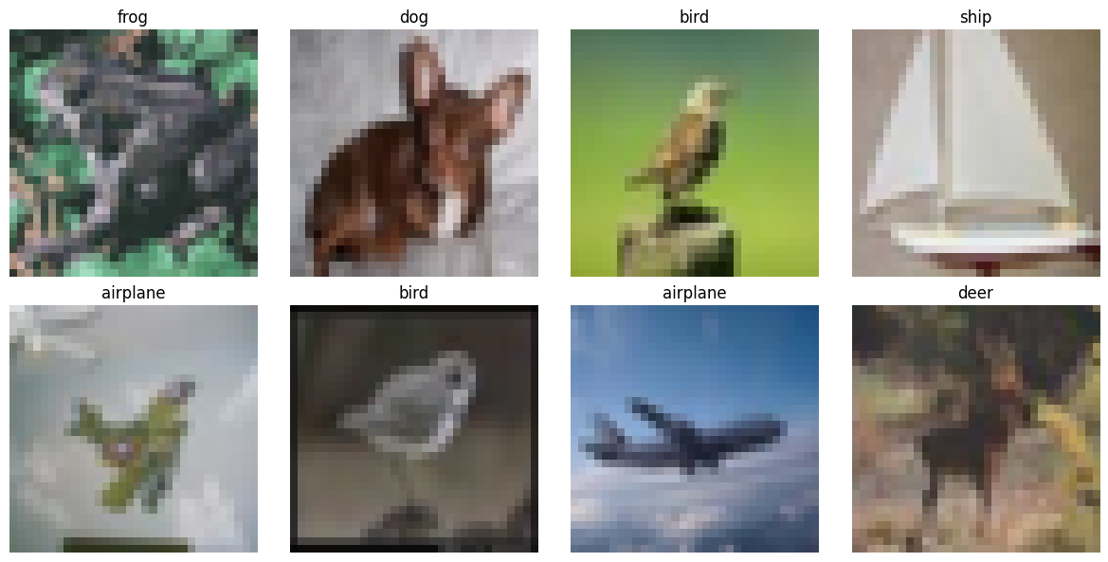
Figure 1: Random sample images from the CIFAR-10 training set

5. Technologies Used
Technology | Purpose
Python | Programming language used for the whole project
Google Colab | Cloud notebook environment; runtime with a Tesla T4 GPU (CUDA)
PyTorch 2.11.0+cu128 | Deep learning framework for building, training and evaluating the model
Torchvision 0.26.0+cu128 | CIFAR-10 dataset, image transformations and pretrained ResNet18 model
NumPy | Numerical operations and handling of predictions
Matplotlib | Plotting sample images, training curves and the confusion matrix
scikit-learn | Classification report and confusion matrix

The libraries were imported and the computing device was checked at the start of the notebook. Training used the GPU (Tesla T4), which is much faster than a CPU for convolutional networks.
Code:
import torch
import torchvision
import torchvision.transforms as transforms
import torch.nn as nn
import torch.optim as optim
import matplotlib.pyplot as plt
import numpy as np

print("Libraries imported successfully!")
print("PyTorch version:", torch.__version__)
print("Torchvision version:", torchvision.__version__)
Output:
Libraries imported successfully!
PyTorch version: 2.11.0+cu128
Torchvision version: 0.26.0+cu128
Code:
device = torch.device("cuda" if torch.cuda.is_available() else "cpu")
print("Device:", device)

if torch.cuda.is_available():
print("GPU:", torch.cuda.get_device_name(0))
else:
print("GPU is not available. Training will use CPU.")
Output:
Device: cuda
GPU: Tesla T4

6. Data Preprocessing
Before the images can be fed to the pretrained network they must be converted into the format it expects. The following preprocessing steps were applied to both the training and the test images:
- Resize to 224 × 224: CIFAR-10 images are only 32 × 32 pixels, while ResNet18 was pretrained on ImageNet images of 224 × 224 pixels. All images were therefore resized to 224 × 224.
- Conversion to tensor: images are converted from PIL format to PyTorch tensors with pixel values scaled to the range 0–1.
- Normalization: each colour channel is normalized using the ImageNet mean [0.485, 0.456, 0.406] and standard deviation [0.229, 0.224, 0.225], because the pretrained weights were trained with the same statistics.
The test images use only these deterministic steps, so that the evaluation is consistent and repeatable.
Code:
test_transform = transforms.Compose([
transforms.Resize((224, 224)),
transforms.ToTensor(),
transforms.Normalize(
mean=[0.485, 0.456, 0.406],
std=[0.229, 0.224, 0.225]
)
])
The datasets were then wrapped in PyTorch DataLoaders, which supply the data in mini-batches of 64 images. The training data is shuffled at every epoch, while the test data is kept in a fixed order.
Code:
train_loader = torch.utils.data.DataLoader(
train_dataset,
batch_size=64,
shuffle=True,
num_workers=2,
pin_memory=True
)

test_loader = torch.utils.data.DataLoader(
test_dataset,
batch_size=64,
shuffle=False,
num_workers=2,
pin_memory=True
)

print("DataLoaders created successfully!")
Output:
DataLoaders created successfully!

7. Image Augmentation
Data augmentation artificially increases the variety of the training data by applying small random changes to the images. This helps the model generalize better and reduces the risk of overfitting. Two augmentations were applied to the training images only:
- RandomHorizontalFlip: randomly mirrors the image left to right.
- RandomRotation(10): randomly rotates the image by an angle of up to 10 degrees.
Augmentation is not applied to the test images, so that the reported test performance reflects the model on unmodified data.
Code:
train_transform = transforms.Compose([
transforms.Resize((224, 224)),
transforms.RandomHorizontalFlip(),
transforms.RandomRotation(10),
transforms.ToTensor(),
transforms.Normalize(
mean=[0.485, 0.456, 0.406],
std=[0.229, 0.224, 0.225]
)
])

print("Image transformations created successfully!")
Output:
Image transformations created successfully!

8. Transfer Learning
Transfer learning is a technique in which a model trained on one large task is reused as the starting point for a different but related task. The early layers of a CNN learn general visual features such as edges, textures and shapes, which are useful for almost any image problem. Only the last layers are specific to the original task.
In this project the following transfer learning strategy (feature extraction) was used:
- A ResNet18 model with pretrained ImageNet weights was loaded from torchvision.
- All pretrained layers were frozen, so their weights are not updated during training.
- The original final fully connected layer (1000 outputs for ImageNet) was replaced by a new linear layer with 10 outputs, one for each CIFAR-10 class.
- Only this new layer is trained on CIFAR-10.
This makes training fast and needs far less computation than training the full network.
Code:
from torchvision.models import resnet18, ResNet18_Weights

weights = ResNet18_Weights.DEFAULT
model = resnet18(weights=weights)

print("Pretrained ResNet18 loaded successfully!")
Output:
Pretrained ResNet18 loaded successfully!
Code:
for param in model.parameters():
param.requires_grad = False

print("Pretrained layers frozen.")
Output:
Pretrained layers frozen.
Code:
num_features = model.fc.in_features
model.fc = nn.Linear(num_features, 10)
model = model.to(device)

print("Final classification layer replaced.")
print(model.fc)
Output:
Final classification layer replaced.
Linear(in_features=512, out_features=10, bias=True)

9. ResNet18 Model
ResNet (Residual Network) is a family of deep CNN architectures that use skip connections, also called residual connections. A skip connection adds the input of a block to its output, which makes very deep networks much easier to train and avoids the vanishing gradient problem. ResNet18 is the smallest standard member of the family and has 18 weighted layers: one initial convolution, 16 convolution layers inside eight residual blocks, and one final fully connected layer.
Stage | Description | Output size
conv1 | 7 × 7 convolution, 64 filters, stride 2, with batch normalization and ReLU | 112 × 112
maxpool | 3 × 3 max pooling, stride 2 | 56 × 56
layer1 | 2 residual blocks, 64 channels | 56 × 56
layer2 | 2 residual blocks, 128 channels | 28 × 28
layer3 | 2 residual blocks, 256 channels | 14 × 14
layer4 | 2 residual blocks, 512 channels | 7 × 7
avgpool | Global average pooling, giving a 512-dimensional feature vector | 1 × 1
fc (replaced) | Linear(512 → 10); the only trainable layer in this project | 10

The new final layer has 512 × 10 weights plus 10 biases, that is 5,130 trainable parameters. The whole network has about 11.2 million parameters, so less than 0.05% of the parameters are trained. All other layers keep their pretrained ImageNet weights.

10. Training
The model was trained using the cross-entropy loss function, which is the standard loss for multi-class classification, and the Adam optimizer. Because the pretrained layers are frozen, the optimizer was given only the parameters of the new final layer.
Parameter | Value
Model | ResNet18 (pretrained, backbone frozen)
Loss function | CrossEntropyLoss
Optimizer | Adam (applied to model.fc parameters)
Learning rate | 0.001
Batch size | 64
Number of epochs | 5
Input size | 224 × 224 × 3
Hardware | Tesla T4 GPU (CUDA) on Google Colab

Code:
criterion = nn.CrossEntropyLoss()
optimizer = optim.Adam(
model.fc.parameters(),
lr=0.001
)

print("Loss function and optimizer created.")
Output:
Loss function and optimizer created.
In every epoch the model processes all training batches. For each batch it performs a forward pass, computes the loss, back-propagates the gradients and updates the weights. The loss and the number of correct predictions are accumulated to report the average training loss and training accuracy of the epoch.
Code:
num_epochs = 5

train_losses = []
train_accuracies = []

for epoch in range(num_epochs):
model.train()
running_loss = 0.0
correct = 0
total = 0

for images, labels in train_loader:
images = images.to(device)
labels = labels.to(device)

optimizer.zero_grad()
outputs = model(images)
loss = criterion(outputs, labels)
loss.backward()
optimizer.step()

running_loss += loss.item()
_, predicted = torch.max(outputs, 1)
total += labels.size(0)
correct += (predicted == labels).sum().item()

epoch_loss = running_loss / len(train_loader)
epoch_accuracy = 100 * correct / total

train_losses.append(epoch_loss)
train_accuracies.append(epoch_accuracy)

print(
f"Epoch [{epoch+1}/{num_epochs}] "
f"Loss: {epoch_loss:.4f} "
f"Accuracy: {epoch_accuracy:.2f}%"
)
Output:
Epoch [1/5] Loss: 0.6583 Accuracy: 77.18%
Epoch [2/5] Loss: 0.6559 Accuracy: 77.26%
Epoch [3/5] Loss: 0.6533 Accuracy: 77.54%
Epoch [4/5] Loss: 0.6508 Accuracy: 77.56%
Epoch [5/5] Loss: 0.6453 Accuracy: 77.84%

11. Training Accuracy and Loss
The training accuracy and loss recorded after each epoch are summarized below and plotted in Figures 2 and 3.
Epoch | Training Loss | Training Accuracy (%)
1 | 0.6583 | 77.18
2 | 0.6559 | 77.26
3 | 0.6533 | 77.54
4 | 0.6508 | 77.56
5 | 0.6453 | 77.84

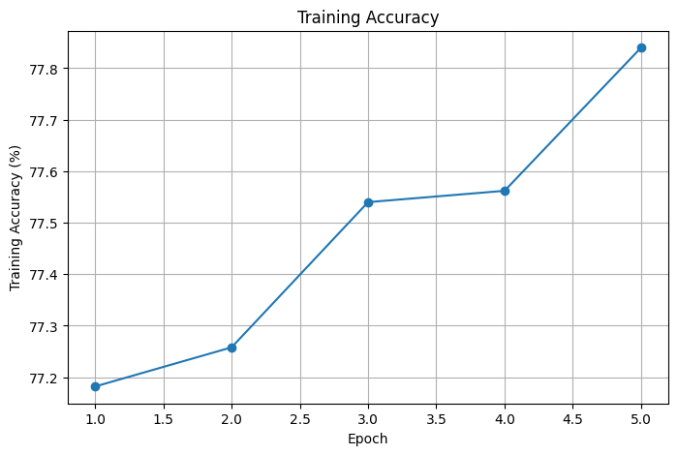  Figure 2: Training accuracy per epoch | 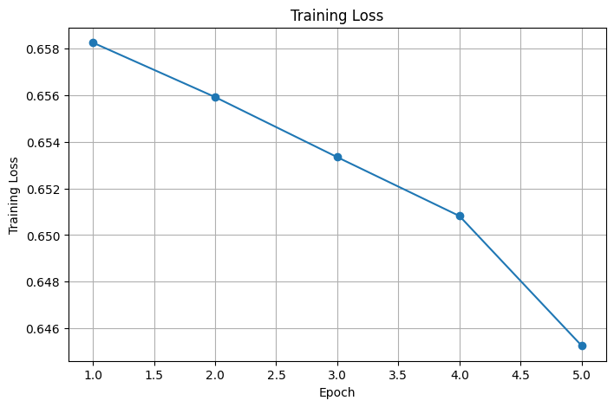  Figure 3: Training loss per epoch
Observation: The training loss decreased in every epoch, from 0.6583 to 0.6453, and the training accuracy increased from 77.18% to 77.84%. The model already reached a high accuracy in the first epoch because the frozen ResNet18 backbone provides strong pretrained features. Afterwards the improvement is gradual, which is expected since only a single linear layer is being trained. The curves have not flattened completely, which suggests that a small additional gain may be possible with more epochs.

12. Model Evaluation
After training, the model was switched to evaluation mode and tested on all 10,000 test images, which were not used for training. Gradient computation was disabled to save memory and time. The predictions and true labels were stored so that the detailed metrics could be computed afterwards.
Code:
model.eval()

correct = 0
total = 0
all_predictions = []
all_labels = []

with torch.no_grad():
for images, labels in test_loader:
images = images.to(device)
labels = labels.to(device)

outputs = model(images)
_, predicted = torch.max(outputs, 1)

total += labels.size(0)
correct += (predicted == labels).sum().item()

all_predictions.extend(predicted.cpu().numpy())
all_labels.extend(labels.cpu().numpy())

test_accuracy = 100 * correct / total
print(f"Test Accuracy: {test_accuracy:.2f}%")
Output:
Test Accuracy: 80.57%
The model achieved a test accuracy of 80.57% on the CIFAR-10 test set. This is higher than the final training accuracy of 77.84%. A likely reason is that the training accuracy is measured on augmented images (random flips and rotations) while the weights are still changing during the epoch, whereas the test images are unmodified and are evaluated with the final weights.

13. Classification Report
The classification report gives precision, recall and F1-score for every class. Precision is the fraction of images predicted as a class that truly belong to it, recall is the fraction of images of a class that were found, and the F1-score is the harmonic mean of the two.
Code:
from sklearn.metrics import classification_report, confusion_matrix

print(
classification_report(
all_labels,
all_predictions,
target_names=classes
)
)
Output:
Class | Precision | Recall | F1-score | Support
airplane | 0.78 | 0.85 | 0.81 | 1000
automobile | 0.87 | 0.88 | 0.88 | 1000
bird | 0.79 | 0.71 | 0.75 | 1000
cat | 0.79 | 0.62 | 0.70 | 1000
deer | 0.69 | 0.81 | 0.75 | 1000
dog | 0.77 | 0.78 | 0.77 | 1000
frog | 0.78 | 0.88 | 0.83 | 1000
horse | 0.87 | 0.76 | 0.81 | 1000
ship | 0.86 | 0.87 | 0.87 | 1000
truck | 0.87 | 0.88 | 0.87 | 1000
accuracy |  |  | 0.81 | 10000
macro avg | 0.81 | 0.81 | 0.80 | 10000
weighted avg | 0.81 | 0.81 | 0.80 | 10000

Analysis: The overall accuracy of 0.81 and the macro and weighted averages of 0.81 (precision and recall) and 0.80 (F1-score) show that the model performs consistently across the balanced test set.
- The best results were obtained for the vehicle classes: automobile (F1 0.88), ship (0.87) and truck (0.87). These objects have distinctive shapes.
- Frog also performed well (F1 0.83, recall 0.88).
- The weakest class is cat with an F1-score of 0.70 and the lowest recall of 0.62, meaning that many cat images were assigned to other classes.
- Bird and deer both reached an F1-score of 0.75. Deer has the lowest precision (0.69), so several images of other classes were wrongly predicted as deer.

14. Confusion Matrix
The confusion matrix shows, for each true class (rows), how the test images were distributed over the predicted classes (columns). Bright cells on the diagonal are correct predictions, and any bright cell outside the diagonal is a frequent confusion.
Code:
cm = confusion_matrix(all_labels, all_predictions)

plt.figure(figsize=(10, 8))
plt.imshow(cm)

plt.title("Confusion Matrix")
plt.xlabel("Predicted Label")
plt.ylabel("True Label")

plt.xticks(range(10), classes, rotation=45)
plt.yticks(range(10), classes)

plt.colorbar()
plt.tight_layout()
plt.show()
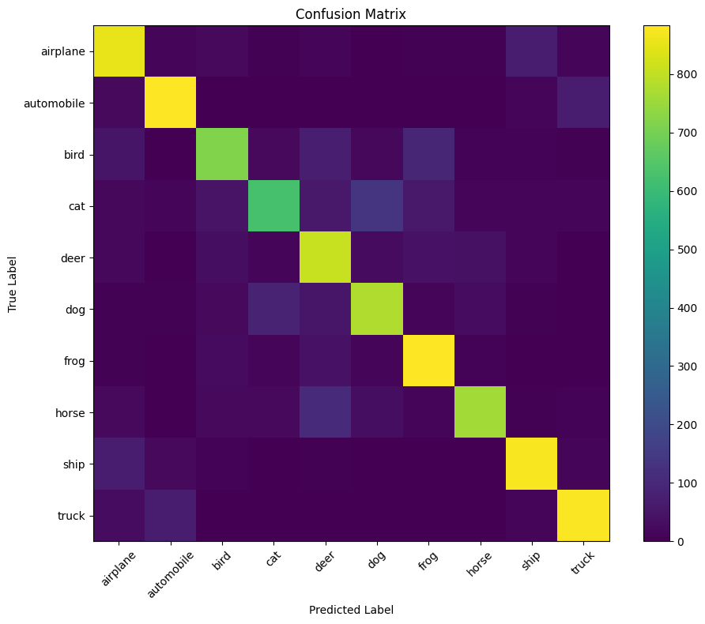
Figure 4: Confusion matrix of the model on the CIFAR-10 test set
The strong diagonal confirms that most images are classified correctly. Automobile, frog, ship and truck have the brightest diagonal cells, while the diagonal cell for cat is visibly weaker, which agrees with its low recall in the classification report. The remaining errors mostly occur between visually similar classes: for example between automobile and truck, between airplane and ship, and between cat and dog.

15. Image Prediction
To check the model on individual images, the first image of the test set was passed through the trained model. Before display, the image was converted back to its original colour range by reversing the normalization.
Code:
model.eval()

image, true_label = test_dataset[0]

with torch.no_grad():
output = model(image.unsqueeze(0).to(device))
predicted_label = torch.argmax(output, dim=1).item()

display_image = image.cpu()
display_image = display_image * torch.tensor([0.229, 0.224, 0.225]).view(3, 1, 1)
display_image = display_image + torch.tensor([0.485, 0.456, 0.406]).view(3, 1, 1)
display_image = torch.clamp(display_image, 0, 1)

plt.figure(figsize=(5, 5))
plt.imshow(display_image.permute(1, 2, 0))
plt.title(
f"True: {classes[true_label]} | "
f"Predicted: {classes[predicted_label]}"
)
plt.axis("off")
plt.show()
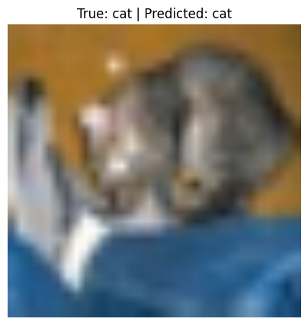
Figure 5: Prediction on the first test image (True: cat, Predicted: cat)
The model correctly predicted the class cat for this image. Next, predictions were made for the first batch of eight test images and displayed together with their true labels (Figure 6).
Code:
model.eval()

images, labels = next(iter(test_loader))
images = images.to(device)
labels = labels.to(device)

with torch.no_grad():
outputs = model(images)
predictions = torch.argmax(outputs, dim=1)

plt.figure(figsize=(12, 8))
for i in range(8):
image = images[i].cpu()
image = image * torch.tensor([0.229, 0.224, 0.225]).view(3, 1, 1)
image = image + torch.tensor([0.485, 0.456, 0.406]).view(3, 1, 1)
image = torch.clamp(image, 0, 1)

plt.subplot(2, 4, i + 1)
plt.imshow(image.permute(1, 2, 0))
plt.title(
f"True: {classes[labels[i].item()]}\n"
f"Pred: {classes[predictions[i].item()]}"
)
plt.axis("off")

plt.tight_layout()
plt.show()
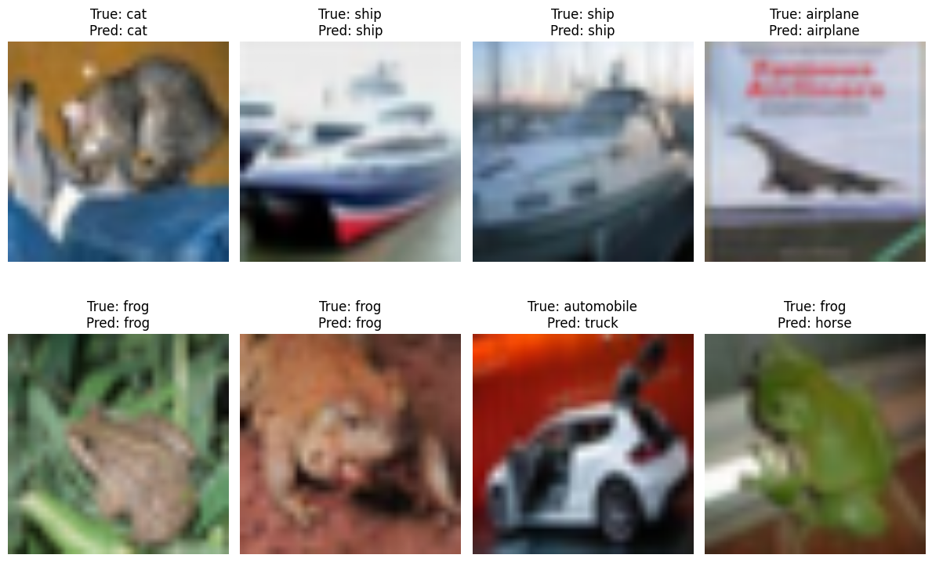
Figure 6: True and predicted labels for eight test images
# | True label | Predicted label | Result
1 | cat | cat | Correct
2 | ship | ship | Correct
3 | ship | ship | Correct
4 | airplane | airplane | Correct
5 | frog | frog | Correct
6 | frog | frog | Correct
7 | automobile | truck | Incorrect
8 | frog | horse | Incorrect

Six of the eight images were classified correctly. The two errors (an automobile predicted as a truck and a frog predicted as a horse) are consistent with the confusions seen in the confusion matrix. This small sample is only for illustration; the overall performance of the model is measured by the test accuracy of 80.57%.

Saving the Trained Model
Finally, the weights of the trained model were saved to a file so that the model can be reloaded later for inference without retraining, and the file was downloaded from Colab.
Code:
torch.save(model.state_dict(), "cifar10_resnet18_model.pth")
print("Model saved successfully!")

from google.colab import files
files.download("cifar10_resnet18_model.pth")
Output:
Model saved successfully!

16. Conclusion
In this project a deep learning image classifier for the CIFAR-10 dataset was built using transfer learning. A ResNet18 network pretrained on ImageNet was used as a fixed feature extractor, its final layer was replaced by a new 10-class layer, and only this layer, with 5,130 trainable parameters, was trained for 5 epochs on a Tesla T4 GPU.
The training loss fell from 0.6583 to 0.6453 and the training accuracy rose from 77.18% to 77.84%. On the 10,000 unseen test images the model reached a test accuracy of 80.57%. The classification report and the confusion matrix showed that vehicle classes such as automobile, ship and truck are recognized best, while cat is the most difficult class (F1-score 0.70), mainly because of confusion with visually similar animals.
The project shows that transfer learning gives good results with little training time and computing effort. It also gave practical experience with the complete deep learning workflow in PyTorch: data loading, preprocessing, augmentation, model adaptation, GPU training, evaluation, visualization and model saving.

17. Future Scope
The results can be improved and the project can be extended in several ways:
- Fine-tuning: unfreeze some of the deeper ResNet18 layers (for example layer4) and train them with a small learning rate so the features adapt better to CIFAR-10.
- Longer training: train for more epochs, use a learning rate scheduler and add early stopping.
- Validation set: separate a validation split from the training data for tuning hyperparameters without using the test set.
- Stronger augmentation: add techniques such as random crop, colour jitter, or CutMix and MixUp.
- Other architectures: compare with larger or more modern models such as ResNet50, EfficientNet or Vision Transformers.
- Improving weak classes: analyze the frequent cat–dog and automobile–truck confusions and handle them with targeted augmentation or class weighting.
- Deployment: build a web application (for example with Streamlit, Flask or Gradio) that loads the saved model and classifies images uploaded by a user.
- Other datasets: apply the same approach to custom or real-world image datasets.

